Coast Soccer Club
Soccer Handbook

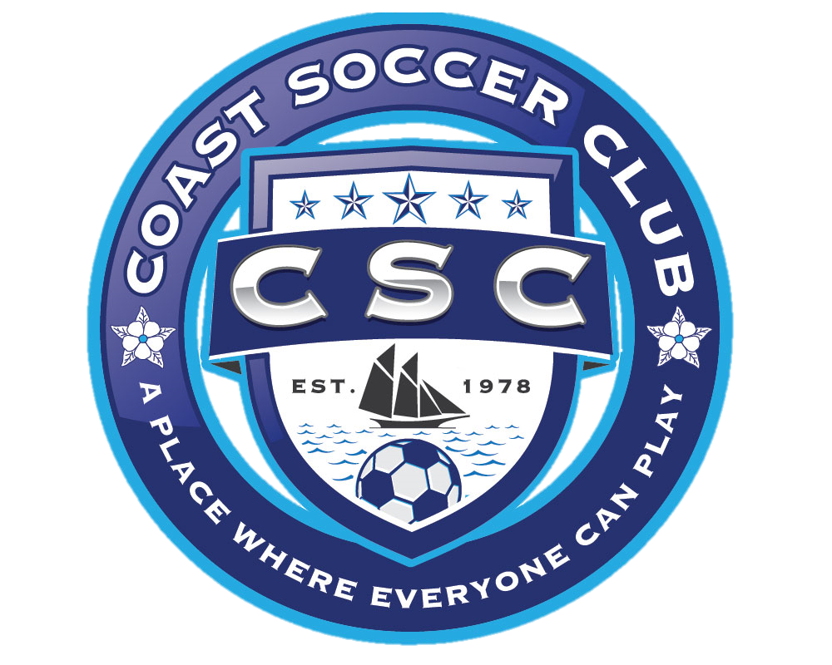
This handbook has been developed as source of information for each head coach. It was created by consolidating information from a multitude of sources into a single, easy to use, document. The information that is contained in this handbook may change from year to year and will be updated annually by the Coast Soccer Club (CSC) Board of Directors. Suggested improvements and corrections to this document are encouraged. Please provide any feedback by using the Suggestion Improvement Form at the back of this handbook. This handbook should be used for guidance. The CSC Board of Directors reserves the right to modify the material in this handbook without notice.
Dear CSC Member:

We welcome you to the Coast Soccer Club (CSC). We are looking forward to working with you and your team during the upcoming season. We believe that everyone should be given an opportunity to experience the rewards and the achievements one gains by being involved in youth sports. As we strive to maintain low cost and high-quality programs, your responsibilities as a player, parent, volunteer, or coach become all the more important.

Participating in recreational youth soccer provides an opportunity to play an enormous part in the community. You will gain a better understanding of the sport of soccer, while participating and demonstrating good sportsmanship, encouraging dedication and commitment, and most of all having fun.

This handbook contains information on program policies and procedures, philosophies, ideas for team organization as well as other valuable information. The purpose of the handbook is to help you become a better player, spectator, or coach, so please take the time to read it.

We wish you the best of luck and hope you have an enjoyable season. We thank you for your interest, time, and concern for the youth in our community.

Sincerely,
CSC Board of Directors

Table of Contents
General Information 4
Mission Statement 4
History 4
OSSO 2017-2018 Season Statistics 4
The Growth of the Club 4
2017-2018 Geographic Distribution of Players 5
Affiliations 6
Season Schedule 6
CSC Board Members 6
Volunteer Coach Responsibilities 8
Time Requirements 8
Available Training 8
Qualifications 9
Age Group Division Rules 10
5U/6U 11
8U 12
10U 13
12U 15
14U 16
16U/19U 17
Game Rules 18
Rule 1: The Game, Field and Equipment 19
Rule 2: The Players 21
Rule 3: Head Coach and Assistants 22
Rule 4: Definitions 26
Rule 5: The Players and Substitutions 28
Rule 6: Offside 28
Rule 7: Duration of the Game 29
Rule 8: Pre-game Conference and the Start of Play 30
Rule 9: Scoring 30
Rule 10: Fouls and Misconduct 31
Rule 11: Kicks and Throw-ins 33
Coach’s Handouts (Example) 37
Coaching Tips 39
Accident Form 42
Major Incident Form 43
Attachment A 44
MSA Policy Manual Code of Ethics for Coaches/Volunteers 44

General Information

Mission Statement

“The Coast Soccer Club will provide a positive environment in which all children have the opportunity to play, learn, and grow in their skills, character, and physical fitness”

History

The Coast Soccer Club (CSC) is a consolidation of the Ocean Springs Soccer Organization (OSSO), Singing River Soccer Club (SRSC), West Jackson County Soccer Club (WJCSC), and West River Soccer Club (WRSC). The overarching organization has been in continuous operation since its founding on March 1, 1978, providing the residents of Gautier, Ocean Springs, St Martin, and Vancleave with a high quality, affordable recreational soccer program for tens of thousands of children. CSC is entirely funded by proceeds from registration, fundraising, and sponsorship. CSC is managed by an elected, all-volunteer Board of Directors and supported by ~190 volunteers including coaches, assistant coaches, and team parents.

OSSO 2017-2018 Season Statistics

CSC provides youth soccer players the opportunity to play recreational (Division 3) and competitive (Division 2) soccer. For the 2017-2018 season, 903 boys and girls from 3 to 15 years old were registered in the CSC Recreational program, playing on 62 teams. There were more than 454 games in the regular season for the U5-U19 age groups played November 2016 through April 2017. People as young as age 12 participated as licensed soccer referees, officiating 12-15 games scheduled each week.
CSC regular season schedule included games with teams from Singing River Soccer Club in Pascagoula, D'Iberville Youth Soccer Organization, Biloxi Soccer Organization, West Jackson County Soccer Club in St. Martin, East Central Soccer Club, Pearl River Futball Club, and South Mississippi Soccer Club in Gulfport. CSC U14-U19 teams played 52 games in February through April 2018, against teams from across the Mississippi Soccer Association (MSA) Southern District. The majority of practice sessions, regular season games, and the CSC Tournament were played at the Ocean Springs Sports Complex on Highway 57 and the Jackson County Soccer Complex on Highway 90 in Gautier. Eight CSC Division 3 teams qualified for the MSA Southern District Tournament in April, hosted by SMSC in Gulfport. Nine competitive (D2) soccer teams, called the CSC Galaxy (U10-U14 Boys & Girls), competed in 10 different tournaments from August through June playing more than 192 games in total.

The Growth of the Club

Over the last three years, the combined club has experienced exponential growth in all divisions. In 2014, OSSO registered 323 players, and as of May 2018, CSC had 1031 registered players and 1209 total registrations, ages 4-17 years old, from all over the Gulf Coast. After the merger with Singing River Soccer Club in Pascagoula during the summer of 2018, we have added another ~330 recreational and ~40 competitive players to our numbers with more expected growth this season.

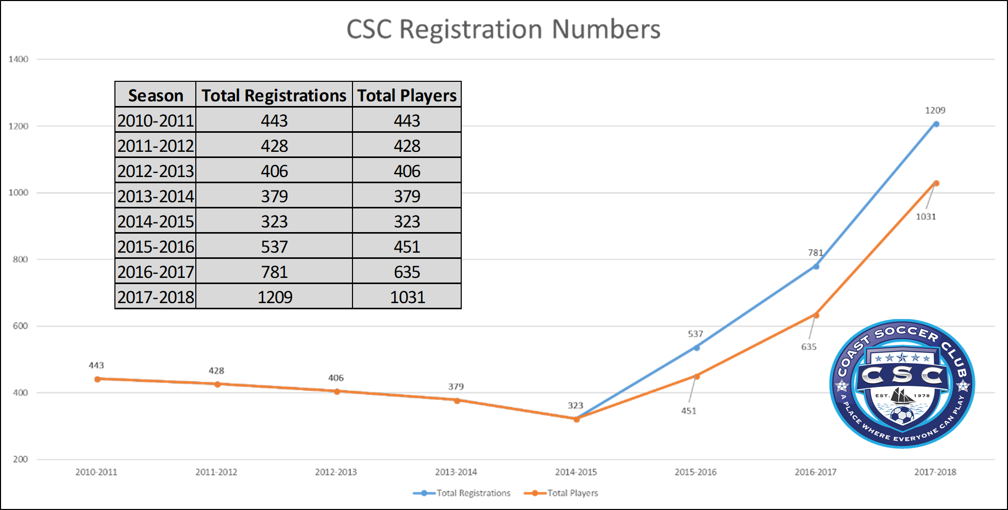
Figure 1: CSC Registration and Player Numbers

2017-2018 Geographic Distribution of Players

With our primary fields in Gautier, Ocean Springs, & St Martin, the large majority of our players reside and go to school in those districts, and we offer our sponsors an excellent opportunity to advertise while directly contributing to the welfare of the youth in Jackson County.

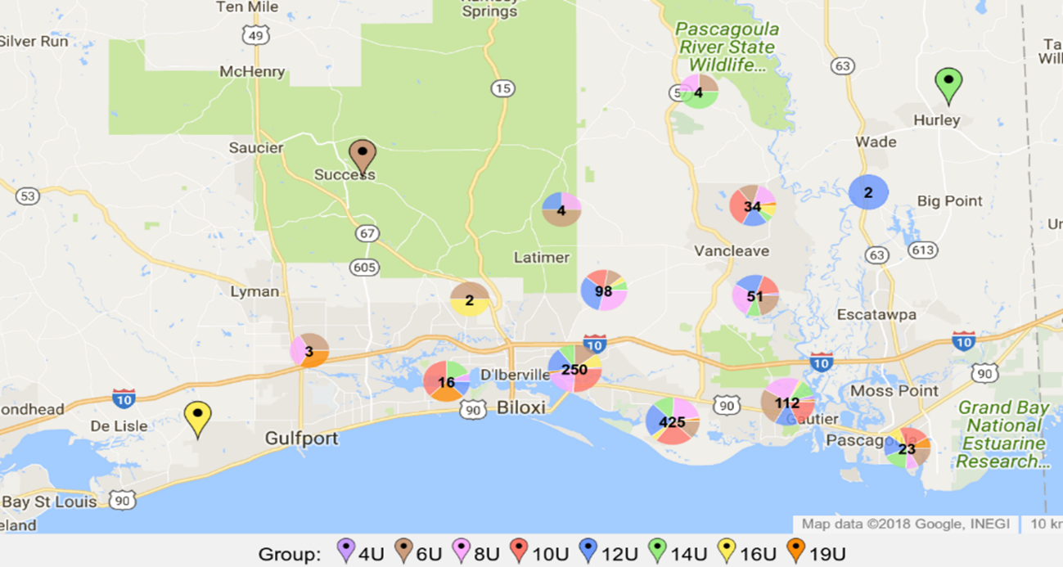
Figure 1: CSC& WJCSC 2017-2018 Consolidated Registrations (1031 total players)

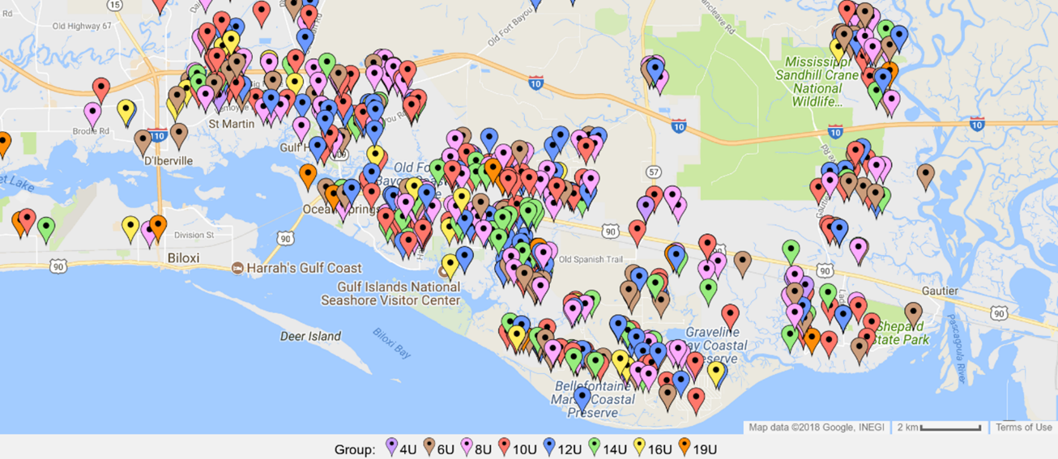
Figure 2: CSC & WJCSC 2017-2018 Consolidated Registrations (OS & Gautier view)

Affiliations

Through its membership in the Mississippi Soccer Association and affiliation with the United States Youth Soccer Association and United States Soccer Federation, CSC provides players the foundation to excel and progress to the highest levels of soccer. Many CSC players continue on to play in Division 1 soccer and on local Middle School & High school soccer teams (Ocean Springs, Vancleave, Gautier, and St Martin).

Season Schedule

2018-2019 Season

Season: Fall Rec (6 Oct 2018- 17 Nov 2018)
Spring Rec (19 Jan - 30 March 2019)

MSA District Tournament – 10U and up 12-14 April 2019
MSA State Tournament – 10U and up 3-5 May 2019

CSC Board Members

President: Ben Wilder 282-9255
Vice President: Cameron Hickey (850) 797-5134
Director of Coaching: Jay Ritchie 344-8775
Recreational Director: Mark Smith 324-2937
Competitive Director: Larry Keenum 239-2306
Treasurer: Jessica Bush 806-4977
Director of Ops (Pascagoula): Barry Jackson 216-6005
Game Coordinator: Crystal Smith 209-0652
Registrar: Jeff Woods 348-1016
Referee Coordinator: Joe Huynh 327-3943
Publicity Coordinator: April Pouliot 761-6272

Volunteer Coach Responsibilities

- Follow City, County, and CSC policies and procedures.
- Supervise the assigned team practice and game conduct.
- Attend all coach’s clinics.
- Establish and maintain a current telephone listing of players, coaches and emergency numbers.
- Attend all scheduled practices and games. Arrive early and stay until the last player has left.
- Organize appropriate practices (location, time, and content).
- Communicate game and practice schedules with team families.
- Inform team members of the need for water and required equipment during practices and games.
- Provide a safe environment for practice and impress upon the team the importance of safety.
- While coaching, always maintain a neat orderly appearance.
- Use positive influence, understanding, and appropriate language when coaching your team.
- Always conduct yourself in a professional manner. Remember that you are representing our community and you are a role model to the team members and in some cases, your team's parents.
- Require appropriate conduct of your team, assistant coach(es), and team parents.
- Provide a positive example, accomplish your responsibilities, and remember that you easily influence the children you coach. The use of tobacco, alcohol, or drugs before or during practice and games is strictly prohibited.
- Participation is the primary objective of our youth soccer program. Coaches are expected to know and follow the substitution rules and minimum playing time rules for the division they are playing.
- Coaches must read and abide by the MSA Policy Manual Code of Ethics for Coaches and Volunteers (Attachment A) at the end of this handbook.

Time Requirements

- Maximum 3 events a week. Each practice or game counts as one event.
- Practice duration should be equivalent to the length of the game per age group. For instance, 6U teams should practice no longer than 45minutes per session.
- Each head coach establishes practices times and locations.
- Games will be scheduled by the organization, including scheduled scrimmages. The CSC Game Coordinator must coordinate any request for changes.

Available Training

- Coaches clinics will be scheduled by CSC or other local soccer organizations.
- Periodic coaches’ meetings will be scheduled throughout the season and CSC will notify each coach of date, time, and location.
- The CSC Handbook will be made available on the CSC website Training page.
- The CSC Technical Director is available for individual counseling and assistance.
- Training information is available on the Internet.

Qualifications

- Successful completion of the Mississippi Soccer Association (MSA) background check.
- Become certified by MSA within 3 months of accepting a coaching position.
- Ability and desire to work in the best interest of the children.
- Read, sign and agree to abide by the MSA Policy Manual Code of Ethics for Coaches and Volunteers (Attachment A) at the end of this handbook.

Sportsmanship

Per our Mission Statement, we have committed to provide an environment in which all children in our community:
- Can have fun
- Learn sportsmanship
- Realize the benefits of teamwork
- Develop soccer skills

Sportsmanship is defined as the ability to be gracious in winning or losing. To accomplish this goal the coaches, the parents, and the players take active roles. As a coach, you are directly responsible for eliminating unsporting behavior from practice and games. A responsible coach will not allow unacceptable behavior and will address the behavior when it occurs. Permitting players to commit acts of taunting without a reprimand or removal from the game, in essence, is telling the players that it is okay to act in an unsporting manner toward competitors.

Likewise, if a coach behaves in an unsporting way, he or she is sending mixed messages. Remember that many times the children will mirror the actions of their coach.

Coaches should have a rule for all parents, explained at the “Parent Orientation Meeting”, that they are not allowed to make critical remarks about the players, the coaches, or the officials. Instead, they are encouraged to provide supportive comments. You should speak privately with parents who do not obey this rule. You need to be firm and fair with parents and emphasize that unsporting behavior is not and will not be tolerated.

Building a child-safe environment

- Ensure that there is always a coach or assistant coach with an approved background check present to lead your practices and games.
- Never transport a child or player as a representative of the league. In fact, it is generally a bad idea to have a player in your vehicle at all (think ahead about how you would handle if it starts to rain and a parent isn’t there to pick up their child).
- Never be alone with someone else’s child. Use the buddy system to ensure that another adult or player is always present (“Hey Steve, can you stay behind for a minute until Trevor’s parents get back?”).
- Never send a child alone to the restroom. If you or your assistant coach need to be the bathroom escort, ensure that at least two players are with you and stand outside the restrooms while they go inside.
- Model appropriate physical contact with children. If they initiate a hug, turn your body to use the open hug/one-arm across the back vice the dual-arm frontal embrace.

Age Group Division Rules

5U/6U

Age Requirements: 4 and 5 years old (players born 2013-2014)

Format: Small Sided Game (See MSA Administration Manual Section 18)

Field Coach: Allowed. This rule is to assist the players in improving their basic soccer strategies. Head Coaches may be on the field on the periphery of the action. Only positive verbal instruction may be used. Negative comments to either team from the other coaches will result in a warning for the first offense and removal to the bench area for subsequent offenses. Warnings are applicable toward the entire coach staff.

Number of players on field: 3 or 4. Must have a minimum of 3 on the field to play. Members from the opposing team can be used in order to conduct play, there should never be a forfeit for lack of players, and 2v2 is acceptable.

Duration of Play: 4 quarters lasting 8 minutes each. Each quarter will be separated by a minimum of 2 minutes and a 5-minute break at halftime.

Substitution: Substitutions may be made at any stoppage of play. Each player must play a minimum of 1/2 of the game (2 quarters) and quarters played must be reported for each player on the game card.

Scoring: The entire ball must cross the goal line within the extents of the goal. The coaches will not keep score and CSC will not retain results of the games.

Ball Size: 3

Penalty kick distance: Not applicable

Free Kicks: All indirect from the point of the infraction. Opponents must be 4 yards from the ball until it is in play.

Goal kick, corner kick, and kick-in: Restart play as appropriate when the ball has completely crossed a boundary line out of the field of play. Opponents must be 4 yards from the ball until it is in play.

Slide tackles and heading: Not permitted. Indirect free kick to restart play.

Offside: Not applicable

Officials: A Referee may or may not be assigned for the games. If a referee is not assigned, the coaches will be responsible for accurate timekeeping and maintaining play within the rules of the age group.

8U

Age Requirements: 6 and 7 years old (players born in 2011 and 2012)

Format: Small Sided Game (See MSA Administration Manual Section 18)

Field Coach: Not allowed. Coaching from the team sideline only.

Number of players on field: 4 (no goalkeeper). Must have a must have a minimum of 3 on the field to play. At the discretion of the opposing coach, members from the opposing team may be used in order to conduct play.

Duration of Play: 4 quarters lasting 10 minutes each. Each quarter will be separated by a minimum of 2 minutes and 5 minutes at halftime.

Substitution: Substitutions may be made at the end of each quarter. For safety reasons, substitutions may occur due to injuries at other times during the game. Referee (or opposing coach) must recognize the substitution of an injured player. Each player must play a minimum of 1/2 of the game (2 quarters) and quarters played must be reported for each player on the game card.

Scoring: The entire ball must cross the goal line within the extents of the goal. Coaches will not keep score and the results of the games will not be retained by CSC.

Ball Size: 3

Penalty kick distance: Not applicable

Free Kicks: All indirect from the point of the infraction.

Throw-in: Restart play with a throw-in. Re-throws permitted for incorrect execution.

Goal Kick and Corner Kick: Restart play as appropriate when the ball has completely crossed the goal line out of the field of play. Opponents must be outside of the goal areas and 4 yards from the ball until it is in play.

Slide tackles and heading: Not permitted. Restart is indirect free kick for the opposing team.

Offside: Not applicable

Officials: A Referee will be assigned for each game.

10U

Age Requirements: 8 and 9 years old (players born in 2009-2010)

Format: Small Sided Game (See MSA Administration Manual Section 18)

Number of players on field: 7 total (6 field & 1 goalkeeper). Must have a minimum of 4 on the field to play. At the discretion of the opposing coach, members from the opposing team may be used in order to conduct play. A team unable to field the minimum numbers of players within 10 minutes of the scheduled game time forfeits the game.

Duration of Play: 4 quarters lasting 12 minutes each. Each quarter will be separated by a minimum of 2 minutes and 5 minutes at halftime. Regular season games may end in a tie.

Substitution: Substitutions may be made at the end of each quarter. For safety reasons, substitutions may occur due to injuries at other times during the game. The Referee must authorize substitution of an injured player. Each player must play a minimum of 1/2 of the game (2 quarters) and quarters played must be reported for each player on the game card. A game card must be submitted to the referee for each game.

Scoring: The entire ball must cross the goal line within the extents of the goal. A goalkeeper may not score directly by kicking or punting from his or her penalty area.

Ball Size: 4

Penalty kick and free kick distance: 7 yards

Throw-in: Restart play with a throw-in. Re-throws not permitted.

Slide tackles: Not recommended

Offside: Applicable as modified by the “build-out line” below

Heading: Not permitted. Restart is indirect free kick for the opposing team.

Officials: A Center Referee and two Assistant Referees will be assigned for each game. On occasion, each team may be required to provide a club linesman in the absence of assistant referees.

Tournament: The CSC tournament details will be established and communicated to coaches in advance of the tournament. The top two teams will advance to the Southern District Tournament. If the Southern District Tournament accepts more than two teams per age/gender group, the CSC Board will determine if more than two teams should attend the Southern District Tournament.

9U/10U USSF Development Rule: "The Build-Out Line"

- A Build-Out Line has been added to the 10U field halfway between the half-line and penalty area in each half.
- The build out line is used to promote playing the ball out of the back in an unpressured setting.
- For any goal kick or when the goalkeeper has the ball, in hand during play from the opponent, the opposing team must move behind the build out line until the ball is put into play.
- Once the opposing team is behind the build out line, the goalkeeper can pass, throw or roll the ball to a teammate (punting and drop kicks are not allowed).
- After the ball is put into play by the goalkeeper, the opposing team can cross the build out line and play resumes as normal.
- If a goalkeeper punts or drop kicks the ball, an indirect free kick should be awarded to the opposing team from the spot of the offense
- If the punt or drop kick occurs within the goal area, the indirect free kick should be taken on the goal are line parallel to the goal line at the nearest point to where the infringement occurred
- The build out line will also be used to denote where offside offenses can be called
- PLAYERS CANNOT BE PENALIZED FOR AN OFFSIDE OFFENSE BETWEEN THE HALFWAY LINE AND THE BUILD OUTLINE, PLAYERS CAN BE PENALIZED FOR AN OFFSIDE OFFENSE BETWEEN THE BUILD OUT LINE AND THE GOAL LINE

Build Out Line Applications
- Ideally, the goalkeeper will wait to put the ball into play once all opponents are past the build out line
- However, the goalkeeper can put the ball into play sooner but he or she does so accepting the positioning of the opponents and the consequences of how play resumes
- Referee can manage the situation with misconduct if deemed appropriate

Referees should be flexible when enforcing the 6 second rule and counting time of possession should only begin when all opponents have moved behind the build out line.

12U

Age Requirements: 10 and 11 years old (players born in 2007-2008)

Format: Small Sided Game (See MSA Administration Manual Section 18)

Number of players on field: 9 total (8 field & 1 goalkeeper). Must have a minimum of 6 on the field to play. At the discretion of the opposing coach, members from the opposing team may be used in order to conduct play. A team unable to field the minimum number of players within 10 minutes of the scheduled game time forfeits the game.

Duration of Play: 4 quarters lasting 15 minutes each. Each quarter will be separated by a minimum of 2 minutes and 5 minutes at the halftime. Regular season games may end in a tie.

Substitution: Substitutions may be made at the end of each quarter. For safety reasons, substitutions may occur due to injuries at other times during the game. The Center Referee must authorize substitution of an injured player. Each player must play a minimum of 1/2 of the game (2 quarters) and quarters played must be reported for each player on the game card. A game card must be submitted to the referee after each game.

Scoring: The entire ball must cross the goal line within the extents of the goal.

Ball Size: 4

Penalty kick and free kick distance: 8 yards

Throw-in: Restart play with a throw-in. Re-throws not permitted.

Offside: Applicable

Heading: Not permitted. Restart is indirect free kick for the opposing team.

Officials: A Center Referee and two Assistant Referees will be assigned for each game. On occasion, each team may be required to provide a club linesman in the absence of assistant referees. Coaches, parents, and players are required to respect the authority of the officials.

Tournament: The CSC tournament details will be established and communicated to coaches in advance of the tournament. The top two teams will advance to the Southern District Tournament. If the Southern District Tournament accepts more than two teams per age/gender group, the CSC Board will determine if more than two teams should attend the Southern District Tournament.

14U

Age Requirements: 12 and 13 years old (players born in 2005-2006)

Schedule: The 14U/16U Age Group Coordinator and CSC Game Coordinator are responsible for scheduling games in these age divisions. CSC pays for the game officials for home games.

Format: Standard FIFA as modified below.

Number of players on field: 11 (or 9 for 9v9). Must have a minimum of 7 (6 for 9v9) on the field to play. At the discretion of the opposing coach, members from the opposing team can be used in order to conduct play. A team unable to field the minimum number of players within 10 minutes of the scheduled game time forfeits the game.

Duration of Play: 4 quarters lasting 17 minutes each. Each quarter will be separated by a minimum of 5 minutes. Regular season games may end in a tie.

Substitution: Substitutions may be made at the end of each quarter. For safety reasons, substitutions may occur due to injuries at other times during the game. The Center Referee must authorize substitution of an injured player. Each player must play a minimum of 1/2 of the game (2 quarters) and quarters played must be reported for each player on the game card. A game card must be submitted to the referee after each game.

Scoring: The entire ball must cross the goal line within the extents of the goal.

Ball Size: 5

Penalty kick distance: 12 yards

Officials: A Center Referee and two Assistant referees will be assigned for each game. On occasion, each team may be required to provide a club linesman in the absence of assistant referees. Coaches, parents, and players are required to respect the authority of the officials.

Tournament: Depending on the number and performance of teams in these age groups, the CSC Board will determine if any teams qualify for the Southern District Tournament.

16U/19U

Age Requirements: 16U (14 and 15 years old); 19U (16, 17, & 18 years old)

Schedule: The 16U/19U Age Group Coordinator and CSC Game Coordinator are responsible for scheduling games in these age divisions. CSC pays for the game officials for home games.

Format: Small sided game.

Number of players on field: 7 total (6 field & 1 goalkeeper). Must have a minimum of 4 on the field to play. At the discretion of the opposing coach, members from the opposing team may be used in order to conduct play. A team unable to field the minimum numbers of players within 10 minutes of the scheduled game time forfeits the game.

Duration of Play: 2 halves of 25 minutes each. Each half will be separated by a minimum of 5 minutes. Regular season games may end in a tie.

Substitution: Substitutions may be made at a stoppage of play as authorized by the referee. For safety reasons, substitutions may occur due to injuries at other times during the game. The referee must authorize substitution of an injured player. Each player must play a minimum of 1/2 of the game.

Scoring: The entire ball must cross the goal line within the extents of the goal.

Ball Size: 5

Penalty kick distance: 10 yards

Free kick and corner kick distance: 8 yards

Offside: Not applicable

Officials: A Center Referee (grade 8 minimum) will be assigned for each game. Coaches, parents, and players are required to respect the authority of the officials.

Tournament: Depending on the number and performance of teams in these age groups, the CSC Board will determine if any teams qualify for the Southern District Tournament.

Game Rules

The rules in this handbook are for guidance only and are superseded by the latest version of the FIFA rules. The CSC board reserves the right to interpret the rules in the best interest of the mission of the organization. Issues or concerns requiring CSC Board interpretation must be submitted using the Suggestion Improvement Form.

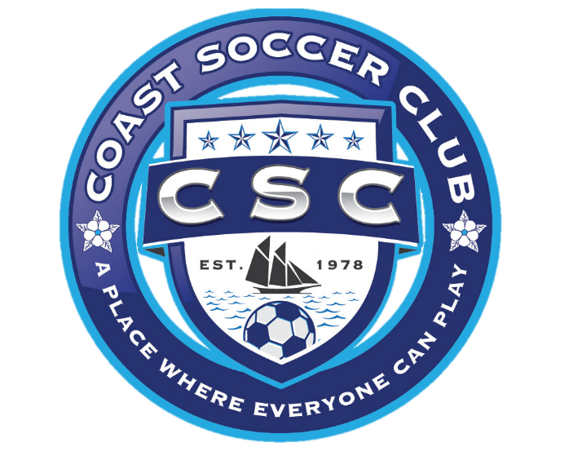

Rule 1: The Game, Field and Equipment

Youth Soccer: A game played between two teams on a rectangular field having goal line at each end and whose object is to legally put the ball between the goal posts and below the crossbar of the opposing team's goal.

FIFA rules apply to all situations not specially covered by this manual.

Philosophy: The philosophy of the Coast Soccer Club is to provide a recreational program allowing participants the chance to learn and experience the fundamentals of good sportsmanship through a wide variety of team and individual activities.

The purpose of the CSC program is to provide an enjoyable learning experience for children. The physical, psychological, and emotional well being of the participants is of paramount concern.

The CSC objectives are:

- To provide a progression of learning from one division to the next, by adopting the rules recommended by United States Youth Soccer to give the players game experience and to improve their individual skills and knowledge of the activity.

- To provide a recreational program designed to provide each participant an equal opportunity to learn and improve from the beginning to the end of the season.

- To provide volunteer role models, who will motivate all participants to learn and improve.

- To facilitate a higher level of self-esteem for the children involved.

WARNING to Parents, Players, and Guardians: Although participation in supervised athletics and activities may be one of the least hazardous in which any youth will engage, by its nature, participation in athletics include a risk of injury which may range in severity from minor to long term catastrophic.

Although serious injuries are not common in supervised programs, it is impossible to eliminate this risk. Participants have the responsibility to help reduce the chance of injury. Players must obey all safety rules, report all physical problems to their coaches, follow a proper conditioning program, and inspect their own equipment daily.

Injury and Insurance: MSA carries secondary insurance coverage on each player that picks up after the primary insurance requirements are met and may be subject to a deductible if the primary insurance deductible has not been met. It is the responsibility of the coach to make sure that only children registered with CSC practice or play during soccer events. Individuals not registered with CSC are responsible for any and all charges resulting from a medical emergency.

Participation: Teams are allowed to have 3 events per week. An event is a practice or a game. CSC recommends that practice duration are equivalent to the game durations for each age group. Never leave a player alone or unsupervised at practices or games.

Event Location: Practices must be scheduled at one of the 5 main complexes listed on our website which are specifically defined in the league’s insurance clause. Failure to use assigned practice locations and follow all league policies may increase the personal liability of a coach in the event of injury or mishap, so please protect yourself and coordinate with our Directors of Operations to ensure that you are properly assigned to a practice location.

The head coach schedules practices. Field space and parking is limited and must be shared with other recreational sports programs in all of our communities. Likewise, city & county-owned property is centrally managed via formal agreements with the municipal parks and recreation departments, so please do not just jump onto a space other than our primary complexes. Practice space is extremely limited, therefore tolerance and cooperation with other teams is required.

Games will typically occur at the team’s home complex. Depending on the number of teams in each age group, some games may be scheduled with neighboring soccer organizations that may require travel to a nearby soccer facility.

Weather Policy: The sport of soccer is played in most weather conditions. The Director of Coaching and/or the Referee Coordinator will assess the safety of the playing conditions at the fields on game day. If the playing conditions are considered to be safe, the games will proceed. Any team unable to field the minimum number of players at the scheduled game time will forfeit the game. Each Director of Operations may also cancel practices and games at their respective sports complexes due to weather conditions in order to maintain the condition of the fields. If games or practices must be postponed or canceled, participants will be contacted in advance (if possible) by CSC via Facebook post and email. The general rule is to be prepared to play unless notified by CSC.

Game Officials: The game official(s) will be scheduled and assigned by the Referee Coordinator. Any changes requested must be addressed to the Referee Coordinator and Game Coordinator in advance. An incident report must be filled and submitted to an CSC Official the next business day documenting any major events occurring during the game.

Field: Field dimensions vary from site to site.

6U: Each team’s coaches, players and parents/spectators may occupy opposite sidelines of the field. The teams will be limited to the sidelines from goal area to goal area. One coach from each team is permitted on the field during the game. Coaches are responsible for the control of the players, parents, and spectators. The Referee may suspend play until the coach controls the players, parents, and spectators.

8U through 16U: The coaches and players from both teams will be on the same sideline of the field. Parents and spectators for both teams will be located on the opposite side of field from the coaches and players during game play. The coaches and players will be limited to the sideline from penalty area line to penalty area line. Coaching by coaches, parents, or spectators from behind the goal lines is not permitted. The parents and spectators are limited to the sidelines from goal area to goal area. No one may obstruct the view or movement of the assistant referees along the boundaries of the field.

Coaches are responsible for the behavior of the players, parents, and spectators. The referee may suspend play until the coach controls the players, parents, and spectators.

Equipment: Players are responsible for:

Shin Guards - must be worn at all practices and games and be covered by socks.
Shoes - soccer shoes are recommended and must conform to FIFA specifications. Soccer shoes have no "toe cleat" (football cleats) and no exposed, sharp surfaces (baseball cleats or spikes). Athletic shoes or tennis shoes are permissible.

Ball Size:

Age Groups | Ball Size
5U, 6U, 8U | 3
10U, 12U | 4
14U, 16U | 5

Casts/Knee braces: Hard casts or hard splints of any material, even padded, are not permitted. Knee braces may be used provided hinges are covered on both sides and all edges of the brace must be padded. Any portion of the brace made of hard material must be padded. The referee is the final authority concerning the legality of equipment and must approve the safety of any casts or braces before the player may participate in the game.

Other: Each player shall properly wear the required equipment while participating in practices or games.

Rule 2: The Players

Roster: Size of the roster is established with the objective of creating viable teams and maximizing player playing time. The Head Coach of the team must contact the CSC Registrar when players quit. A request for replacement players must be made in writing to the CSC Registrar. The CSC Board will determine what action should be taken.

Any coaches attempting to alter their team roster will be released from coaching duties and subject to further sanctions. Players may not transfer from one team to another.

Player Conduct: A player receiving a red card ejection or a coach ejected by a game official will be suspended for the remainder of that game plus the next scheduled game. The player's head coach and/or ejecting game official are responsible for reporting the ejection to the CSC Vice President or other CSC Official. If an ejected player plays in the game or ejected coach returns to the game, the game may be suspended.

Age Groups: Age group is determined by the player’s age as of January 1 of the year at the start of the season. The age requirements are strictly enforced.

Age Groups:

Age Group | Ages | Gender | Format
6U | 4 & 5 | Mixed | Small sided
8U | 6 & 7 | Boys and Girls | Small sided
10U | 8 & 9 | Boys and Girls | Small sided
12U | 10 & 11 | Boys and Girls | Small sided
14U | 12 & 13 | TBD | Standard (modified FIFA)
16U | 14 & 15 | TBD | Small sided

Players must participate in the age groups in which they belong. Requests to play up an age group are considered by the CSC Board on a case-by-case basis. Requests for a player to play up an age group must be provided to the CSC Registrar prior to being placed on a team. The request for a player to play up an age group must include rationale.

Rule 3: Head Coach and Assistants

The head soccer coach is in a position to set high standards of sportsmanship. Positive role modeling is the single most important factor when coaching young athletes. The head coach must make sure every athlete experiences personal growth and development, while maximizing participation of every player.

Responsibilities:

- Attend a coaching clinic and become certified to coach in the age group assigned.
- Remember that the game belongs to the athletes and will encourage every athlete to play.
- Place each player in situations where the athlete has a maximum opportunity to achieve success, based on individual strengths.
- Conduct practices and games so that all players have an opportunity to improve their skills through active participation.
- Protect the health and safety of the players.
- Follow the substitution rule for the age group he/she coaches.
- Learn the fundamental skills, age-appropriate teaching techniques, and strategies of the sport.
- Be familiar with the goals and objectives of the program and strive to achieve these goals by communicating them to the players and their parents.
- Treat each individual involved in the program with respect and dignity.
- Uphold the authority of game officials. Disputes will be handled through appropriate channels.
- Refrain from abusive language or actions.
- Encourage parents and spectators to display good sportsmanship at all times.
- Remain tobacco-free, alcohol-free, and drug-free during all games and practice sessions and any time he or she is in contact with players or other members of CSC.

Conduct: Head coaches are in a position to set a high example of good sportsmanship and leadership. Head coaches are responsible for the conduct of their team whether on the field or on the sidelines.

- Coaches found using profanity, tobacco, or alcohol in the presence of the team shall be subject to immediate suspension.
- Praise player’s efforts in public.
- Limit criticism.
- Refrain from running up the score.
- Play every player in accordance with the substitution and 50% playing time rules.
- Accept decisions of game officials as fair and called to the best of their abilities.
- Do not criticize the opposing team or their fans by abusive words, obscene gestures or in any other way.
- Do not intimidate the opposing team by chants and gestures before, during or after the game.
- Apply good common sense to decisions during practice and games.

Head coaches ejected from a game by the referee or other CSC Official shall be subject to the following at a minimum to be determined by a Disciplinary Committee as defined by the CSC Constitution and By-laws:

- First Offense: A scheduled meeting with the CSC Board prior to the next scheduled game. The coach will not coach the next scheduled game. The head coach will be placed on probation for the remainder of the season.
- Second Offense: Automatic suspension from the program for one-year (365 days from the date of suspension). Coaches who are suspended must attend all training workshops and clinics offered by CSC before being assigned a head coach position for an CSC-sponsored soccer team.

If the ejected coach refuses to leave the premises, the game may be suspended.

Participation: Head coaches are solely responsible to make sure all players play the mandatory 50% of game time. Players in the 6U through 14U age groups must play a minimum of 2 quarters each game they attend. Players in the 16U age group must play a minimum of half of each game they attend.

If you are approached during a practice by a parent or a child wanting to play on your team, do not promise them a spot. Ask them to contact the CSC Registrar for registration information. Fill-in registration is on a space-available basis and the CSC Registrar will accomplish all player registrations and team assignments.

Game Day Coaching: Head or assistance coaches shall not act in an unsporting manner. Examples of unsporting behavior are listed below, but not limited to:

- Using profanity, insulting, or vulgar language or gestures.
- Attempting to influence a decision by an official.
- Disrespectfully addressing an official.
- Indicating objections to an official's decision.
- Using illegal communication equipment.
- The failure of the team to be ready at the start of play.
- The failure of the head coach, following verification, to have their player(s) wear legal/required equipment.
- Being on the field of play (except in 6U age groups).
- Being outside the team sideline area (Penalty Area to midfield).
- Being on the wrong side or goal ends of the field.

The penalty for unsporting behavior is a warning for the first infraction. The second infraction is considered flagrant and the offending coach shall be ejected from the game. The referee may suspend the game in order to maintain the safety of all participants. Head coaches are responsible to for controlling parents and spectators. Unsporting behavior will not be tolerated.

Practice Responsibilities: Developing a good working relationship with the parents of the players is also as important as the relationship you have with your athletes. With little effort you can have parents working with you and appreciating your efforts. We have found that the coach holding a parent orientation meeting prior to the first practice may avoid many of the problems between parents and coaches. This meeting serves a number of useful purposes, including:

- Enable parents to understand the objectives of the program.
- Allow parents to become acquainted with you.
- Inform parents about the nature of the sport.
- Inform parents about what is expected of their child and what is expected of them.
- Enable you to understand parent's concerns.
- Establish clear line of communication between you and the parents.

Conducting a Parent Orientation meeting is important and valuable in having a successful and enjoyable season.

Call 911 in the case of an emergency during practices or games. Ask the operator to dispatch the necessary emergency services for assistance.

Several teams will practice at the same practice location. All designated teams have the right to practice at the same site. A cooperative effort among all teams and coaches is necessary to provide every team the opportunity to conduct a quality practice. Coaches may move their practices to another site in the same vicinity.

All coaches are responsible for instructing players on safety and age-appropriate rules, techniques, and strategies involved in participation in soccer.

To coach youth soccer, head coaches must understand the basic rules and age-appropriate skills and strategies of the sport. The Mississippi Soccer Association (MSA) requires all coaches to obtain a MSA soccer coaching certification within three months of taking on a coaching position within a MSA member organization.

Assistant Coach: Head coaches are responsible and encouraged to obtain a reliable coaching staff. Friends, parents, and other interested individuals are good resources in developing an efficient coaching staff. Examples of roles that an assistant may help with but are not limited to:

- Conducting practice.
- Organizing team and parent events.
- Developing a telephone tree.
- Game day management.
- Game day spectator control.

All volunteers who interact with children must submit to an MSA background check form prior to participating as an assistant coach, coach, manager, or team parent. Assistant coaches are welcome and encouraged to attend all coach training sessions available to the head coach.

Qualities of a Good Head Coach:

Role Model: Coaches wear several hats: teacher, parent, and friend just to name a few. Your coaching may be the only positive reinforcement some children receive. Having a good character means modeling appropriate behavior for sports and life. What you say and what you do must be consistent. Be in control of yourself before, during, and after all practices and games.

Patience: Your players are children first and then athletes. Yes, they may make the same mistake over and over, yet remember, they are trying to please you and do better. Here are several ways one can demonstrate engagement and patience:

- Get to know your players' names quickly.
- Empathize with players trying to learn a new skill.
- Be in control of your emotions.
- Keep an upbeat and positive outlook when communicating with your team.

Sense of Humor: It’s alright to laugh with your players. Both coaches and players should enjoy participating in sports.

Organization: You must plan and organize your practices. Organized practice provides players the proper guidance to improve physical stamina and support skill development. Good organizational skills result in a smooth game plan. Know who starts and what substitution pattern to use prior to the game.

Fairness: Watch for undue favoritism with your own children and with players who may be more athletic or skillful than others. It is a quick way to lose credibility with parents and players. Ask yourself a few questions, “Am I only playing the good players to rack up another victory?” or "Does my child always play the entire game because it benefits the team?" Remember, recreational soccer is intended to foster learning, participation, positive sporting behavior, and above all, fun playing soccer.

Communication: Be clear and concise when instructing players. When you give instructions to your team, make sure you are talking on a level appropriate for the developmental maturity of the age group. Communication to parents is just as important. Explain your coaching philosophy and outlook for the season. Open communication with parents helps to eliminate difficulties that may occur during the season.

Rule 4: Definitions

Here is a brief list of common definitions head coaches must know:

Advantage: A discretionary judgment, which allows an official to permit play to continue rather than stopping play to address an infraction. This concept is based on the premise that the infraction did not put the offending team at an advantage, or the infraction, if called, may take away a favorable opportunity for the offended team.

Caution Player: A player notified by an official that his/her actions are not in the best interest of the contest. The cautioned player must be shown the yellow card.

Charge: An act by a player employing body contact to cause an opposing player to lose or give up possession of the ball. A fair charge must be executed within the extents that are set down in the rules. An unfair charge is called at the discretion of the referee. A particularly dangerous or flagrant charge may be grounds for caution or ejection from the game.

Deliberate foul: An extreme and purposeful planned act. It is done to disrupt the game through willful and repeated acts intended to gain an advantage through the unfair act.

Direct Free Kick: A free kick from which a goal may be scored against an opponent without a second player touching the ball.

Foul: A rule infraction for which a penalty is prescribed.

Free Kick: After play is stopped for a foul, the ball is placed on the ground and while motionless, it is kicked unchallenged in any direction so that it moves prior to being touched by another player.

Goalkeeper Possession: Hands on the ball constitutes possession. Safety is of paramount concern when interpreting this rule to prevent injury to the goalkeeper. Players may not attempt to kick the ball when the goalkeeper has possession.

Handling the Ball: Intentionally playing the ball with one’s hand or arm. The referee has the responsibility to decide if an infraction has been committed or if play will continue due to incidental contact.

Indirect Free Kick: A free kick from which a goal may not be scored unless the ball is played or touched by another player from either team.

Offside: An infraction that occurs when an official judges a player in an offside position and is seeking to gain an advantage from that position at the moment the ball is played. A player cannot be called offside receiving the ball directly from a throw-in or while positioned on their defending half of the field. Rule only applies to 10U and higher age groups.

Penalty Kick: A penalty kick is awarded from the penalty spot to a team because an opponent was charged with one of the major infractions within his/her own penalty area, which requires a direct free kick. This rule only applies to 10U and higher age groups.

Scoring: Each coach will maintain the CSC game card documenting quarters of play for each player of the team. The card will be turned-in to the center referee at the completion of the game. The center referee will maintain control of the game cards, one for each coach, and submit them to the CSC Game Coordinator or other designated CSC Official.

Sliding Tackle: A maneuver in which one or both feet slide on the ground in an attempt to tackle the ball while it is in possession of an opponent. Sliding tackles must never be executed from behind. Legal slide tackles are only allowed for the 10U and higher age groups.

Warning: A verbal admonition to a coach or player for conduct not in the best interest of the game. Repeat warnings necessitate an official caution (yellow card).

Rule 5: The Players and Substitutions

The number of players for teams:

Age Group | Max players on the field | Max players on the roster | Min players on the field
5U/6U | 3 or 4 | 6 or 8 | 2
8U | 4 or 5 | 8 or 10 | 3 or 4
10U | 7 | 14 | 4
12U | 9 | 18 | 6
14U (9v9) | 9 | 18 | 6
14U (11v11) | 11 | 22 | 7
16U | 7 | 14 | 4

Games will proceed as scheduled if both teams field at least the minimum number of players. The game may be played with an uneven number of players on each team as long as the number of players is within the minimum and maximum range for the age group. 6U/8U games should never be forfeited due to lack of players - try and play the game with whoever shows up, including exchanging players to establish the same number of players on the field for each team.

Substitutes:

6U through 14U: Substitutions may be made at the end of each quarter. For safety reasons, substitutions may occur due to injuries at other times during the game. The Center Referee must authorize substitution of an injured player. Each player must play a minimum of 1/2 of the game (2 quarters for 6U through 14U or 40 minutes for 16U).

16U: Free substitution allowed at a stoppage of play when authorized by the referee, either team to substitute an unlimited number of players.

Incoming substitutes shall report to the nearest game official and enter the field at the centerline. When an entry is taking place on a throw-in, a goal kick or a corner kick, the substitute must have reported to the game official prior to the stoppage. Entry onto the field of play by a substitute is prohibited without the approval of an official.

Team Captain: Each team will designate a team captain on the field who is the team representative for the coin toss at the start of the match.

Rule 6: Offside

The Offside Rule applies to 10U (with modifications due to build-out lines), 12U, and 14U age groups: The intent of this rule is to prohibit players from taking advantage of advanced attacking positions behind the opposing team's defensive players. Briefly, an attacking player is offside when advantage is gained by being in an offside position unless:

- There are at least two defenders (goalkeeper counts as one) between the receiver and opponent's goal line at the time the ball is played (passed, not received) forward.
- The receiver is in their own half of the field (or behind the build-out line for 10U).
- An opponent last intentionally touched the ball.
- The receiver is behind the ball when it is passed (even is not offside).

It is the position of the receiving player when the ball was kicked, and not the position where the ball was received that decides whether or not the receiver is offside. The referee must decide whether this attacking player is intentionally interfering with play or seeking to gain advantage by taking up this advanced position; therefore, the referee may not always make an offside ruling, even though a player was in an offside position. The re-start for an offside infraction is an indirect free kick at the location of the offside infraction.

A player shall not be penalized for an offside position, if he/she receives the ball directly from a:

- Goal Kick
- Corner Kick
- Throw-in
- Drop-ball by a game official

Rule 7: Duration of the Game

Game duration: The following are the age-group guidelines for the duration of the game.
Length of Game:

Age Group | Periods | Duration
6U | 4 quarters | 8 minutes each
8U | 4 quarters | 10 minutes each
10U | 4 quarters | 12 minutes each
12U | 4 quarters | 15 minutes each
14U | 4 quarters | 17 minutes each
16U | 2 halves | 50 minutes total

Suspended Play: The Center Referee shall declare an official game, if one complete half or more of the game has been played. The Center Referee must report the suspension of play and the score to the CSC Game Coordinator by the following day. At the discretion of the CSC Board, games suspended prior to halftime may or may not be rescheduled.

End of Play: A period shall end at the expiration of time and the ball declared dead. Exception: Play shall be extended beyond the expiration of period to permit a penalty kick to be complete. Regular season games that are tied at the end of regulation time will be considered complete games.

Rule 8: Pre-game Conference and the Start of Play

Pre-game Conference: The game official must inspect both teams to verify that all players are properly equipped. Questions of equipment legality must be resolved before the start of play. The game official’s decision is final and protest will not be allowed regarding equipment. Referee will check for:

- Uniform
- Shin guards
- Shoes
- Removal of all jewelry

All players except the goalkeeper must start the game with jerseys tucked into shorts.

Prior to the start of play, both team captains will be summoned to the center of the field for a brief discussion. The captains may be instructed to inform their teams of the special instructions at the discretion of the game officials.

Game Ball: The home team, based on the CSC schedule, is responsible to provided the appropriate size ball for the game.

Coin Toss: The game official will conduct a coin toss at least five minutes before the schedule start time of the game. The visiting team will call the coin toss. The winner of the toss shall choose a goal to attack. The other team will start the game with a kick-off.

Start of Play: When the referee signals with the whistle, a kick-off shall initiate play at the start of each half and after goals. At the moment of the kick-off, all players shall be in their team’s half of the field. Players opposing the kick-off shall maintain an appropriate distance from the ball until it is kicked, depending on the age group and size of the playing field. A goal may be scored directly from a kick-off.

Legal Kick Off: The ball shall be kicked while it is stationary in the center of the field of play. A legal kick off must move the ball onto the opposing team’s half of the field. If the kick-off is taken in a way that does not constitute a legal start of play (ball does not pass into the opposing half of the field), the ball may be replaced on the center of the field and re-kicked by the same team.

After a legal kick-off: Any player except the one who initiated the kick-off may play the ball. The original kicker may not play the ball until another player on either team has played it.

Re-start: Indirect free kick is awarded to the opponent at the location of the infraction.

Rule 9: Scoring

Goals: A goal is one point. A goal is scored when the entire ball passes completely beyond the goal line, between the goal posts, and under the cross bar, provided it has not been intentionally thrown, carried, or propelled by the hand or arm of a player of the attacking team. The winning team is the team scoring the greater number of goals during the game. A ball on the goal line is not considered to have crossed the goal line.

Ways to score a goal: A goal may be scored during play directly from a:

- Direct free Kick
- Penalty kick
- Corner kick
- Drop ball
- Goalkeeper throw, punt, or drop kick (except 10U)
- Kick-off

Ways teams cannot score a goal: A goal may not be scored during play directly from a:

- Indirect free kick
- Goal kick
- Throw-in
- Free kick into a team’s own goal

Rule 10: Fouls and Misconduct

Fouls:

Kicking / Striking / Tripping / Jumping: A player shall not intentionally attempt to or succeed in kicking, striking, tripping, or jumping any player. A goalkeeper shall not intentionally strike an opponent by throwing or kicking the ball at an opponent or by pushing an opponent with the ball while holding it.

Re-start: Direct free kick

Handling: A field player shall be penalized for intentionally handling, carrying, striking, or propelling the ball with a hand or arm up to the shoulder. The referee is the sole authority to determine if a handling infraction has occurred.

Re-start: Direct free kick

Holding or pushing: A player shall not hold or push an opponent with the hand(s) or arm(s) extended from the body. A player shall not place a hand or hands on an opponent in an effort to reach the ball.

Re-start: Direct free kick

Charging: A fair charge is allowed when a player makes non-violent shoulder-to-shoulder contact with an opponent, with the arms and elbow close to the body, at least one foot on the ground and the ball within playing distance.

A player having one or both feet on the ground shall not charge into an opponent who has both feet off the ground. A player shall not charge into the goalkeeper in the penalty area unless the goalkeeper is obstructing the player or dribbling the ball with the feet. The game officials shall eject, without caution, any player who flagrantly fouls a goalkeeper who has possession of the ball.

Re-start: Direct free kick

Note: When a goalkeeper leaves the penalty area they relinquish their rights as a goalkeeper and are considered a field player until they return to the penalty area.

Obstruction: Obstruction is the intentional act by a player not in possession of the ball or not attempting to play the ball, running between an opponent and the ball or using the body as an obstacle. A player not attempting to play the ball, but remaining between the ball and an opponent, may be legally charged from behind provided the charge is not violent or dangerous and the ball is within playing distance.

Re-start: Indirect free kick

Dangerous Play: A player shall not engage in dangerous play. Dangerous play is defined as any act the official considers likely to cause injury to any player. This includes playing in such a manner that could cause injury to self or another player.

Re-start: Indirect free kick

Restrictions on the Goalkeeper: From the moment the goalkeeper takes control of the ball with the hands and within the penalty area, the goalkeeper may hold the ball up to 6 seconds and may move anywhere within the penalty area with the ball in his or her hands.

On any occasion when a player deliberately kicks the ball to their own goalkeeper, the goalkeeper is not permitted to touch the ball with their hands. A player may play the ball to their own goalkeeper using the head only.

Re-start: Indirect free kick

Misconduct:

Yellow cards: A player shall be cautioned for:

- Entering or leaving the field of play without the permission of an official
- Persistent infringement of any of the rules of the game
- Verbal objection or action in opposition to any decision given by an official (dissent)
- Unsporting behavior
- Any incidental use of vulgar or profane language

Unsporting Behavior Cautions: A caution issued for infringement of the following:

- Encroachment on free kicks.
- Intentional handling by the defense to stop an attack.
- Unnecessary delay (kicking/throwing the ball away in a free kick).

Red cards: A player shall be issued a red card or a coach shall be ejected for exhibiting violent conduct or committing serious foul play such as, intentional foul by a player against an opponent who is moving toward the goal with an obvious opportunity to score, or using foul or abusive language, or a subsequent act of misconduct after having been cautioned.

If the head coach is ejected, an assistant coach specified on the official team roster may replace him or her. If the ejected coach refuses to leave the premises or no authorized assistant coach is available, the game will be suspended. In addition:

- The head coach must meet with the CSC Board prior to the next scheduled game. The coach will not coach the next scheduled game.
- If an assistant coach or player is ejected, the ejected person(s) may not continue to participate in the game, nor in the next scheduled game.
- Written reports must be completed and turned in by the head coach and ejecting game official to the CSC Game Coordinator the next business day.
- Ejected players may not be replaced during the game they are ejected.

Any coach who is ejected shall leave the vicinity of the playing area immediately and is prohibited from any further contact, direct or indirect, with the team for the remainder of the game.

Rule 11: Kicks and Throw-ins

Free Kick: When the referee stops play due to an infraction, he or she may award a free kick to the team the infraction was committed against. All of these kicks are taken from the point of the infraction with the exception of a penalty kick or an indirect kick awarded against the defending team while in the penalty area.

Opponents must be at least ten yards away (varies based on age group) from the ball unless they are standing on their own goal line between the goal posts. If the free kick is awarded to the attacking team in the defending team’s penalty area, the defending players shall be outside the penalty area in addition to being ten yards from the ball and must remain there until the player taking the penalty kick puts the ball into play.

The penalty kicker may not play the ball a second time until another player from either team has touched the ball.

Types of Free Kicks: There are two types of free kicks, direct and indirect. Each is determined by the seriousness of the infraction. See Rule 10, Fouls and Misconduct for the types of free kicks. There will be no whistle to take the kick unless the referee feels play was stopped for an undue length of time or the kicking team requests the referee to address infringement. In this situation, the players are informed of the restart of play by the whistle.

Penalty Kick (applies to 10U & older age groups):
Awarding a penalty kick: A penalty kick is awarded when a foul, which ordinarily results in the awarding of a direct free kick, occurs within the offending team’s penalty area.

All players except the kicker and the opposing goalkeeper shall be within the field of play but outside the penalty area. Until the ball is kicked, players must be at least ten yards from the penalty kick spot.

The opposing goalkeeper shall stand on the goal line between the goal posts until the ball is kicked. The goalkeeper may move side to side on the goal line, but may not move off of the goal line until the ball is kicked.

Re-start: If the goalkeeper moves illegally and a goal is not scored on the penalty kick, it is retaken.

Kicking a penalty kick: The ball shall be kicked while it is stationary on the ground from the spot or any place on the penalty kick line. To be in play, the ball shall be moved forward. Once the kicker starts movement toward the ball, the kicker must kick the ball. Infractions by the team kicking the ball shall result in a goal kick.

Immediately after the penalty kick, any player except the one who executed the penalty kick may play the ball. The kicker may not play the ball again until another player from either team has played the ball.

Re-start: Goal kick.

Penalty kick at the end of regulation: If the ball touches the goalkeeper before passing between the goal posts when a penalty kick is taken at or after the expiration of time, it does not nullify the goal. If necessary, play may be extended if the penalty kick must be retaken. If a penalty kick is taken after the expiration of time, only the kicker may play the ball (once) with the goalkeeper in place.

Goal Kick:
Awarding a Goal Kick: A goal kick shall be awarded to the defending team when the entire ball crosses the goal line, without scoring a goal, either in the air or on the ground, having last been touched or played by the attacking team.

Players opposing the kicker shall remain outside the penalty area until the ball has cleared the penalty area. A player of the defending team shall kick the stationary ball from the ground from any point within the goal area. A goal kick shall clear the penalty area and enter the field of play. If the ball is not kicked beyond the penalty area, the goal kick shall be repeated. The goalkeeper cannot pick up the ball and play it until after the ball has cleared the penalty area.

Re-start: Indirect free kick awarded from the spot of foul.

Corner Kick:
Awarding a corner kick: A corner kick shall be awarded to the attacking team when the entire ball passes over the goal line, without scoring a goal, either on the ground or in the air, having last been touched or played by the defending team.

Players of the defending team shall be at least ten yards from the corner arc until the ball has been kicked. The ball shall be kicked from the ground within the corner arc at the corner nearest where the ball left the field of play.

An attacking player who is not offside during the corner kick may be put in an offside position during the subsequent play.

After the corner kick, any player except the one who executed the corner kick may play the ball. The kicker may not play the ball until it has been touched or played by another player.

Re-start: Indirect free kick awarded for the spot of the foul.

Throw-in:
Throw-ins from the touchline: A throw-in shall be awarded to a team when the opposing team last touches or plays the ball before the entire ball passes beyond the touchline (side line) either in the air or on the ground. 6U players may kick-in the ball to restart play from the touchline.

The ball shall be thrown in any direction onto the field of play from the point where it crossed the sideline. The player throwing the ball in must be facing the field of play and have both feet on the ground on or outside of the touch line. The thrower shall use both hands with equal force and shall deliver the ball from behind and over the head in a continuous movement. If the ball fails to enter the field of play, it shall be re-thrown.

Re-start: 8U – Re-throw once with instructions from referee. U-10 and up – Throw-in is awarded to the opposing team.

Interference: An opponent shall not interfere with, nor in anyway impede, the actions of the thrower while the throw-in is being taken.

During the throw-in: On a throw-in, the ball is playable when it has left the hands of the thrower and any part of the ball breaks the plane of the touch line. After the throw-in, either team may play the ball. The thrower may not play the ball until it has been touched or played by another player.

Re-start: Indirect free kick awarded to the opponents for the spot of the infraction.
Helpful Hints

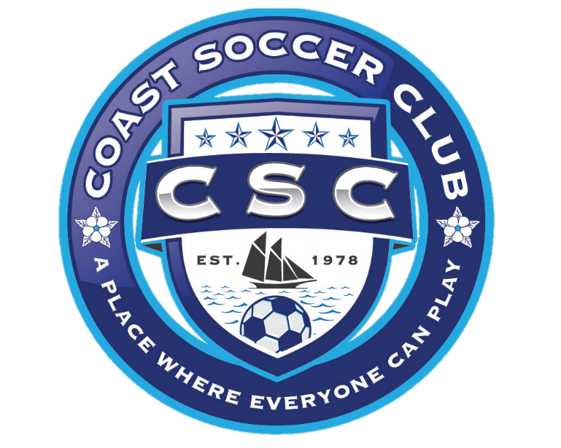

Coach’s Handouts (Example)

Welcome the 20__-20__ soccer season! This handout will provide you with the information to help make this a great soccer season. Please read it and bring up any questions or concerns that you have.

We are the ______ soccer team, under __ division for __ and __ year olds. My name is _________ and I will be your coach this season. This is my ___ season coaching soccer and I have completed the coach’s clinics offered by CSC. Please feel free to call me at home, _________ or at work _________ if you have any questions, concerns, etc.

The goals of this team are to:

- Have fun
- Promote sporting behavior
- Promote good self-esteem
- Provide a safe and healthy athletic opportunity for our children
- Learn about soccer

Parents, coaches, and spectators will conduct themselves in a manner that promotes these goals. Please emphasize sportsmanship and having fun with your soccer player. Motivate your soccer player to do his/her best. De-emphasize the score whether we win or lose. Make all your comments positive and constructive. I encourage you to read any books or articles for more information on children’s recreational activities.

Additional information:

- This team runs on volunteer power. So please volunteer to bring a game snack on the sheet being passed around. Snacks should be something healthy. A fruit drink and sliced oranges are very popular. Please do not bring candy. We will need enough for all the players.
- You may also volunteer to organize the end of the year season party.
- I will also appreciate any parent volunteering to help me during the practices. The quality of coaching will improve tremendously with a little bit of help. Please let me know if you are willing to help. No experience is required. Submitting to a background check is required.

Each parent is responsible for their child during the practice and games. Please notify me if your player must leave the practice or game before the scheduled end.

Please report any accidents and or injuries to me immediately, regardless of how minor the injury may seem.

Please let me know if your player has any physical and or emotional conditions that may require special considerations while participating with our team, even if you have given this information to the organization already.

All practices will be held at ____________ between ______ and ______ PM on ________ and _________. Please have your player at the practice field 5 minutes early. Also, please pick up your child from practice on time.

Personal equipment:

- Shin guards are required and clothing, such as long socks, must cover them.
- Shoes with good traction or soccer cleats are required.
- Jewelry must be removed.
- Eyeglasses must be shatterproof.
- Bring a water bottle to all games and practices.
- Bring a size __ soccer ball to each practice.
- Please mark all your belongings (water bottle, ball, etc.).
- Uniforms (jersey, shorts and socks) will be distributed before the first game.
- Please be at the field 20 minutes before the scheduled start of the game.
- CSC rules state that the coach and players from both teams will be on one side of the field and the parents/spectators will be on the opposite side during the game. (8U and up). Also the spectators are limited from goal box to goal box on the side of the field, and no coaching from the spectator side line or behind the goal lines.

Coaching Tips

Pre-game and half time:

- Bathrooms?
- Drinks?
- Have Fun.
- Instructions to your players.
- Show referee game card filled out with player's names and numbers.
- Goalkeeper jersey/gloves.
- Determine captain(s) in advance.

During the Game:

- Stay calm even if the other coach is not.
- Praise and encourage players. Help them reach their potential.
- Each player must play half of the game (2 quarters or 1 half game depending on age group).
- Switching goalkeepers at quarters is recommended.
- Provide a snack at the end of the game (not half time).

Practice:

- Introduce new skills using the IDEA approach:
Introduce.
Demonstrate.
Explain.
Attend to players practicing.
- Keep practice pace moderate. Pause between activities (2 minutes).
- Adapt activities and durations to mood of players. End each practice with a scrimmage or game-like activity.
- Ask kids to take handouts to parents. Keep track of who received a handout.
- Schedule the first practice when you can have a parent’s meeting.
- Make sure each player has proper equipment.

Forms

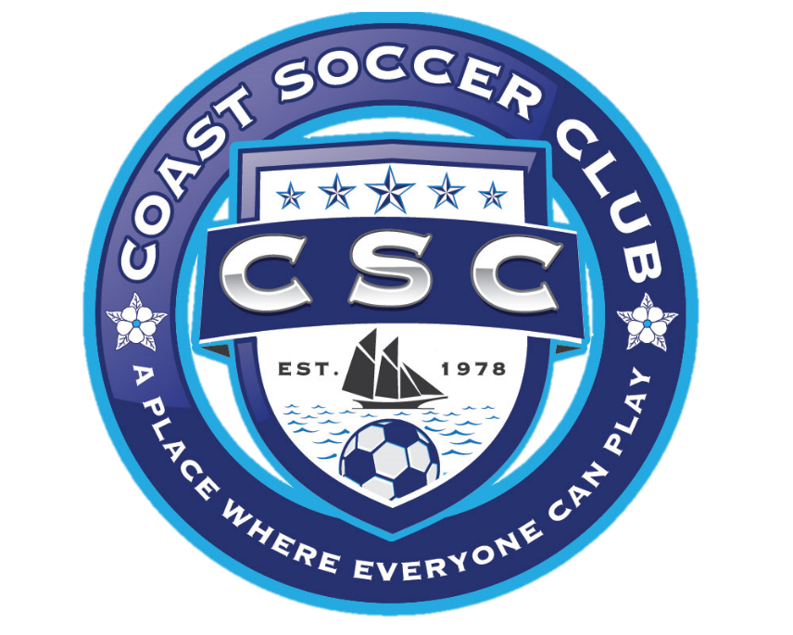
Suggestion Improvement Form

Your feedback is very important tool that CSC Board of Directors uses to facilitate positive changes to the soccer program. In order to capture the problems and proposed solutions, we ask that you complete this form.

Your Name: ____________________________
Your Team Number: ____________________
Date: ____________________

Problem / Concern / Issue: ________________________________________________________________________________________________________________________________________________________________________________________________________________________________________________________________________________________________________________________________________________________________________________________________________________________________________________________________________________________________________________________________________________________________________________________________________________________________________________________________________________________________________________________________________________________________________________________________________________________________________________________________________________________________________________________________________________________________________________________________________________________________________________________________________________

Proposed solution(s):
________________________________________________________________________________________________________________________________________________________________________________________________________________________________________________________________________________________________________________________________________________________________________________________________________________________________________________________________________________________________________________________________________

Signature:____________________________

The CSC Board will review each suggestion improvement form and take the appropriate action. Thank you for your contribution to the program. You can use the back of this sheet to provide expanding information if required. Submit this form to an CSC Board Member or mail to CSC, PO Box 368, Ocean Springs, MS 39566 or go to www.coastsoccerclub.org and click “Facebook” to leave a message for CSC.

Accident Form

Name of Injured person: _______________________________________________
Address:__________________________________________ Zip: ______________
Phone:____________________ Gender:__________ Age:_______
Date:________________ Time of Accident: _______________
Place of Accident:______________________________________________________
______________________________________________________

What was the person doing at the time of accident?_________________________
_____________________________________________________________________

How did the injury occur?________________________________________________
______________________________________________________________________

What caused the injury? _______________________________________________
______________________________________________________________________

Describe in detail the injury and indicate the part of the body that was affected?
______________________________________________________________________________________________________________________________________________

Describe the treatment of the accident? ______________________________________________________________________________________________________________________________________________

Name and address of physician/hospital: ______________________________________________________________________________________________________________________________________________

Name(s) and address(es) of witness(es):
- _____________________________________________________________________
- _____________________________________________________________________
- _____________________________________________________________________

Describe any act or condition, which may have contributed to the accident.
______________________________________________________________________________________________________________________________________________

What corrective action could be taken to eliminate the problem from re-occurring?
______________________________________________________________________________________________________________________________________________
Signed: ________________________ Date:_______________________________
This report must be delivered to an CSC Official within 24 hours of accident.

Major Incident Form

Date: __________ Time: ______________ Location:__________________________

Age Group: ____ Team #: __________________ vs. Team #: __________________

Referee’s Name: _____________________________

Coach’s Name: _____________________________

Coach’s Address: _______________________________________________________

Coach’s Home Phone: __________________ Work Phone: ____________________

In detail, describe the incident: ________________________________________________________________________________________________________________________________________________________________________________________________________________________________________________________________________________________________________________________________________________________________________________________________________________________________________________________________________________________________________________________________________________________________________________________________________________________________________________________________________________________________________________________________________________________________________________________________________________________________________________________________________________________________________________________________________________________________________________________________________________________________________________________________________________________________________________________________________________________________________________

Recommendation: ____________________________________________________________________________________________________________________________________________________________________________________________________________________________________________________________________________________________

Signature of Coach: _____________________________________________________

This report must be submitted to a CSC Official within 24 hours of the incident.

Attachment A

MSA Policy Manual Code of Ethics for Coaches/Volunteers

a. I will never place the value of winning before the safety and welfare of all players.
b. I will always show respect for players, other coaches, and game officials.
c. I will lead by example, demonstrating fair play and sportsmanship at all times.
d. I will demonstrate knowledge of the rules of the game, and teach these rules to my players.
e. I will never use abusive or insulting language. I will treat everyone with dignity.
f. I will not tolerate inappropriate behavior, regardless of the situation.
g. I will not allow the use of anabolic agents or stimulants, drugs, tobacco, or alcohol by any of my players.
h. I will never knowingly jeopardize the eligibility and participation of a student-athlete.
i. Youth have a greater need for example than criticism. I will be the primary soccer role model.
j. I will at all times conduct myself in a positive manner.
k. Coaching is motivating players to produce their best effort, inspiring players to learn, and encouraging players to be winners.
l. Coach’s actions on sidelines during games shall be in the spirit of "good sportsmanship" at all times. Profanity, profane gestures, arguing, inciting disruptive behavior by spectators and/or players, or any conduct not in the spirit of good sportsmanship, shall require disciplinary action from the affiliate.
m. Alcohol, illegal drugs and unauthorized prescription drugs shall not be possessed, consumed or distributed before, during or after any game or at any other time at the field and/or game complex.

Failure to comply with the MSA Code of Ethics may result in the suspension of the privilege to participate in MSA sanctioned events, for the following periods:

● 1st offense suspension minimum fifteen (15) days to a maximum of five (5) years
● 2nd offense suspension minimum of one (1) year to a maximum of ten (10) years
● 3rd offense suspension minimum of five (5) years to a maximum of twenty-five (25) years.

NOTE: Any individual charged with a violation of this Code of Ethics, except for cautions and send-offs as stated in the Laws of the Game, Tournament Rules or MSA Disciplinary policy including allegations of referee abuse or assault, shall be afforded due process as defined in MSA’s rules before the implementation of any suspension.

Signed_________________________

Date _________________________

